|  |  |  |
| --- | --- | --- |
|  | **ST. FRANCIS INSTITUTE OF TECHNOLOGY**  **Mount Poinsur, Borivali (West), Mumbai-400103**  **Department of Information Technology**  **Information Technology Students’ Association (ITSA)** |  |

18th March 2021

**Intra-Department Debate Competition.**

ITSA had organized an Intra-Department Debate Competition for all the students of the SFIT. The report for the event is as follows:

|  |  |  |
| --- | --- | --- |
| * Event | - | Intra-Department Debate Competition |
| * Date | - | 4th and 5th March 2021 |
| * Time | - | 4.00 pm onwards |
| * Venue * No of Participants * Winners | -  -  - | Google Meet  18  1.PiyushSurkar and Shivam(first place)  2.Nikhil Lobo and Roxanne Kadam(runner up) |

The winners were given prizes (first prize Rs.500 and second prize Rs.300) and certificates.

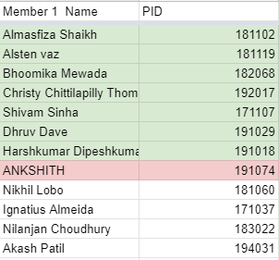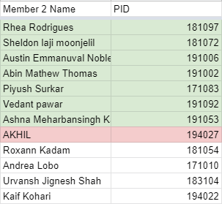

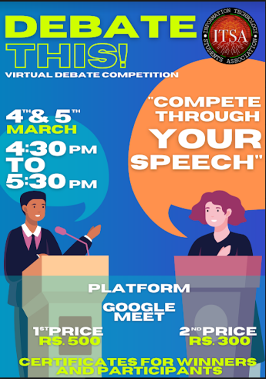

**The rules and regulations of the competition were as follows:**

• One speaker, from each team, gives an introductory clause regarding the topic being

debated. (1 minute each)

• In the Rebuttal round the speaker from each group present further arguments in support

of their stand, identifies areas of conflict, and answers questions that may have been

raised by the opposition speaker. (5 minutes)

• Conclusion clause is presented by each team in the end (1 minute each)

• Your mic and video should always be on during the duration of the debate. In the case of noise in your background, only unmute when you have to speak.

• The debate will be for 10 mins, a hand will be raised by the moderator when the last 2 mins are left. The participants must conclude their given topic once the hand is raised from the moderator.

• The use of cell phones is not allowed during the debate, you can use them to prepare for it within the time given.

• Make sure you have proper internet connectivity. The participant’s audio must be clear.

•Yourmic and video should always be on during the duration of the debate. In the case of noise in your background, only unmute when you have to speak.

**The topics for Day 1 were as follows;**

1. Should human cloning be legalized?

2. All students should be provided with an after-school job or internship.

3. Traditional schooling is effective than homeschooling considering social values.

4. Does technology prevent more crime or does it enable more people to commit crimes?

5. Are Android devices better and cheaper than Apple?

6. Juveniles making tiktoks and other trending dance videos is detrimental to society.

7. Humans should invest in technology to explore and colonize other planets.

8. Bitcoin and other cryptocurrencies should be encouraged or banned.

9. Is GST good or bad?

10. Should online schools go for 4 days a week, instead of 5 days a week work schedule?

11. There is a need to restore internet neutrality.

12. Technology will be man’s downfall.

13. Vaccination should be mandatory for COVID19.

14. Should potential employers consider an applicant’s social media during a job application?

15.Are electric cars actually better for the environment?

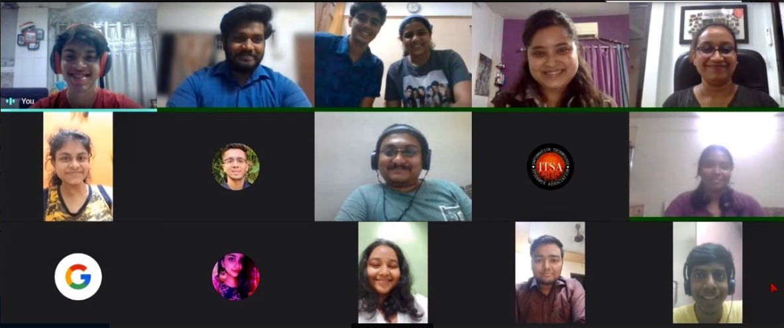

Day 1 began with president Joshua welcoming and introducing our respected judges and fellow participants. The rules for the debate and the assessment style were explained to the participants.

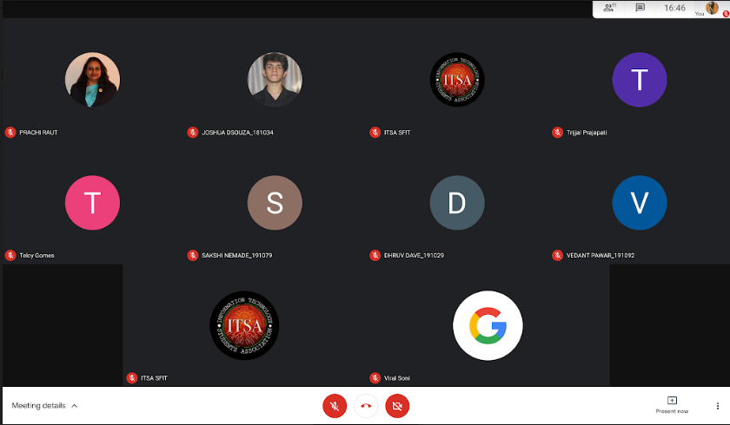

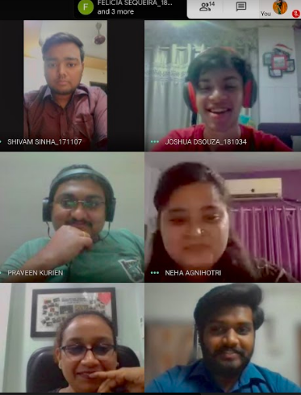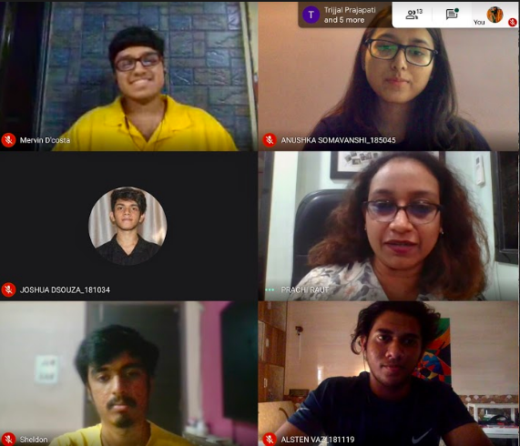

**The topics for Day 2 were as follows;**

1. The academic merit of one is influenced by their gender.

2. The Theory of Evolution is not true.

3. Should driverless vehicles be allowed on the same road as manual drivers?

4. Should more governments incentivize their citizens to use renewable energy resources in their homes like solar, wind, etc.?

5.Kids’ mental disorders are caused only by wrong role models in the family

6. Can we have free education around the world?

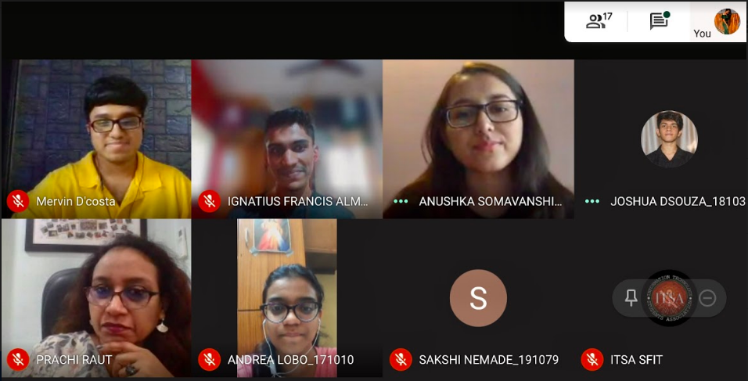

**The Judges for the competition:**

Day 1

Session 1 - DrPrachiRaut

Session 2 - Mr. Praveen Kurien

Day 2

Dr .PrachiRaut

Mr Praveen Kurien

MrsNehaAgnihotri

**Results of the competition:**

Winners :

1.PiyushSurkar

2.Shivam

Runnerup:

1.Nikhil lobo

2.Roxannkadam

|  |  |  |
| --- | --- | --- |
| **Mrs. Shree Jaswal** | **Mrs. GrinalTuscano** | **Dr. Joanne Gomes** |
| **(ITSA Co-ordinator)** | **(ITSA Co-ordinator)** | **(HOD-INFT)** |